CLIENT ENGAGEMENT

An Enterprise RAG Platform for Multi-Source Project Intelligence
Enterprise Software & Engineering Operations · Hybrid RAG (Vector + Graph) · Agentic AI Platform
Focus areas: AI/ML · Data Architecture · Cloud · AWS · Data Governance · Analytics · Performance Optimization · Scalability

1. EXECUTIVE SUMMARY
I architected a BYOM/BYOC (bring-your-own-model / bring-your-own-cloud) enterprise Retrieval-Augmented Generation platform that lets engineering and delivery teams ask natural-language questions across GitHub, Confluence, JIRA, and ServiceNow — source code, documentation, tasks, and support tickets — and get end-to-end project visibility, task tracking, and support-status answers, without compromising data compliance.
2. CLIENT CONTEXT (ANONYMIZED)
The client is a technology organization running distributed engineering and delivery teams whose project knowledge was scattered across four disconnected systems of record (source control, documentation, task tracking, and support ticketing), with strict requirements around data safety, model choice, and compliance that ruled out simply routing everything through a single third-party hosted LLM API.
3. BUSINESS CHALLENGE
No single system gave a complete picture of a project's state. Answering a question like "why is this ticket blocked" typically meant manually cross-referencing a JIRA ticket, its linked ServiceNow case, the relevant Confluence documentation, and the actual code change in GitHub. This made project visibility slow, inconsistent across teams, and dependent on institutional memory rather than the underlying systems of record.
4. TECHNICAL CHALLENGES
- Ingesting and indexing four structurally different content types — source code, wiki documentation, structured task records, and support tickets — into a retrieval system able to answer questions spanning all of them together.
- Capturing both semantic similarity (what a piece of text means) and structural/relationship information (what links to what — which commit closed which ticket, which document describes which service) in one retrieval layer.
- Supporting bring-your-own-model and bring-your-own-cloud requirements — multiple model backends, with some data unable to leave a specific compliance boundary — without forking the platform per deployment.
- Measuring retrieval quality rigorously enough to trust the system in production, not just "it looks right in a demo."
- Preventing PII leakage and inappropriate content from reaching either the retrieval layer or the generated answer.
- Keeping cost and latency under control as usage scaled, given that both LLM context size and inference cost grow with naive retrieval.
5. SOLUTION / ARCHITECTURE
Source content from GitHub, Confluence, JIRA, and ServiceNow flows through a high-speed ingestion layer into a dual index: a vector store (Milvus in production, Chroma DB during early proof-of-concept) for semantic retrieval, and a graph store (Neo4j) for structural and relationship retrieval. A multi-stage retrieval and ranking layer fuses results from both indexes, gated by ML-powered guardrails for PII detection and content filtering, then handed to LangChain/LangGraph for agentic orchestration across retrieval, tools, and generation. A horizontally scalable FastAPI/Redis/Celery serving layer fronts a BYOM/BYOC model layer spanning AWS Bedrock, SageMaker endpoints, and custom deployments, with semantic caching and context compression controlling token cost, and RAG-specific KPI monitoring plus LangSmith/CloudWatch observability wired throughout.
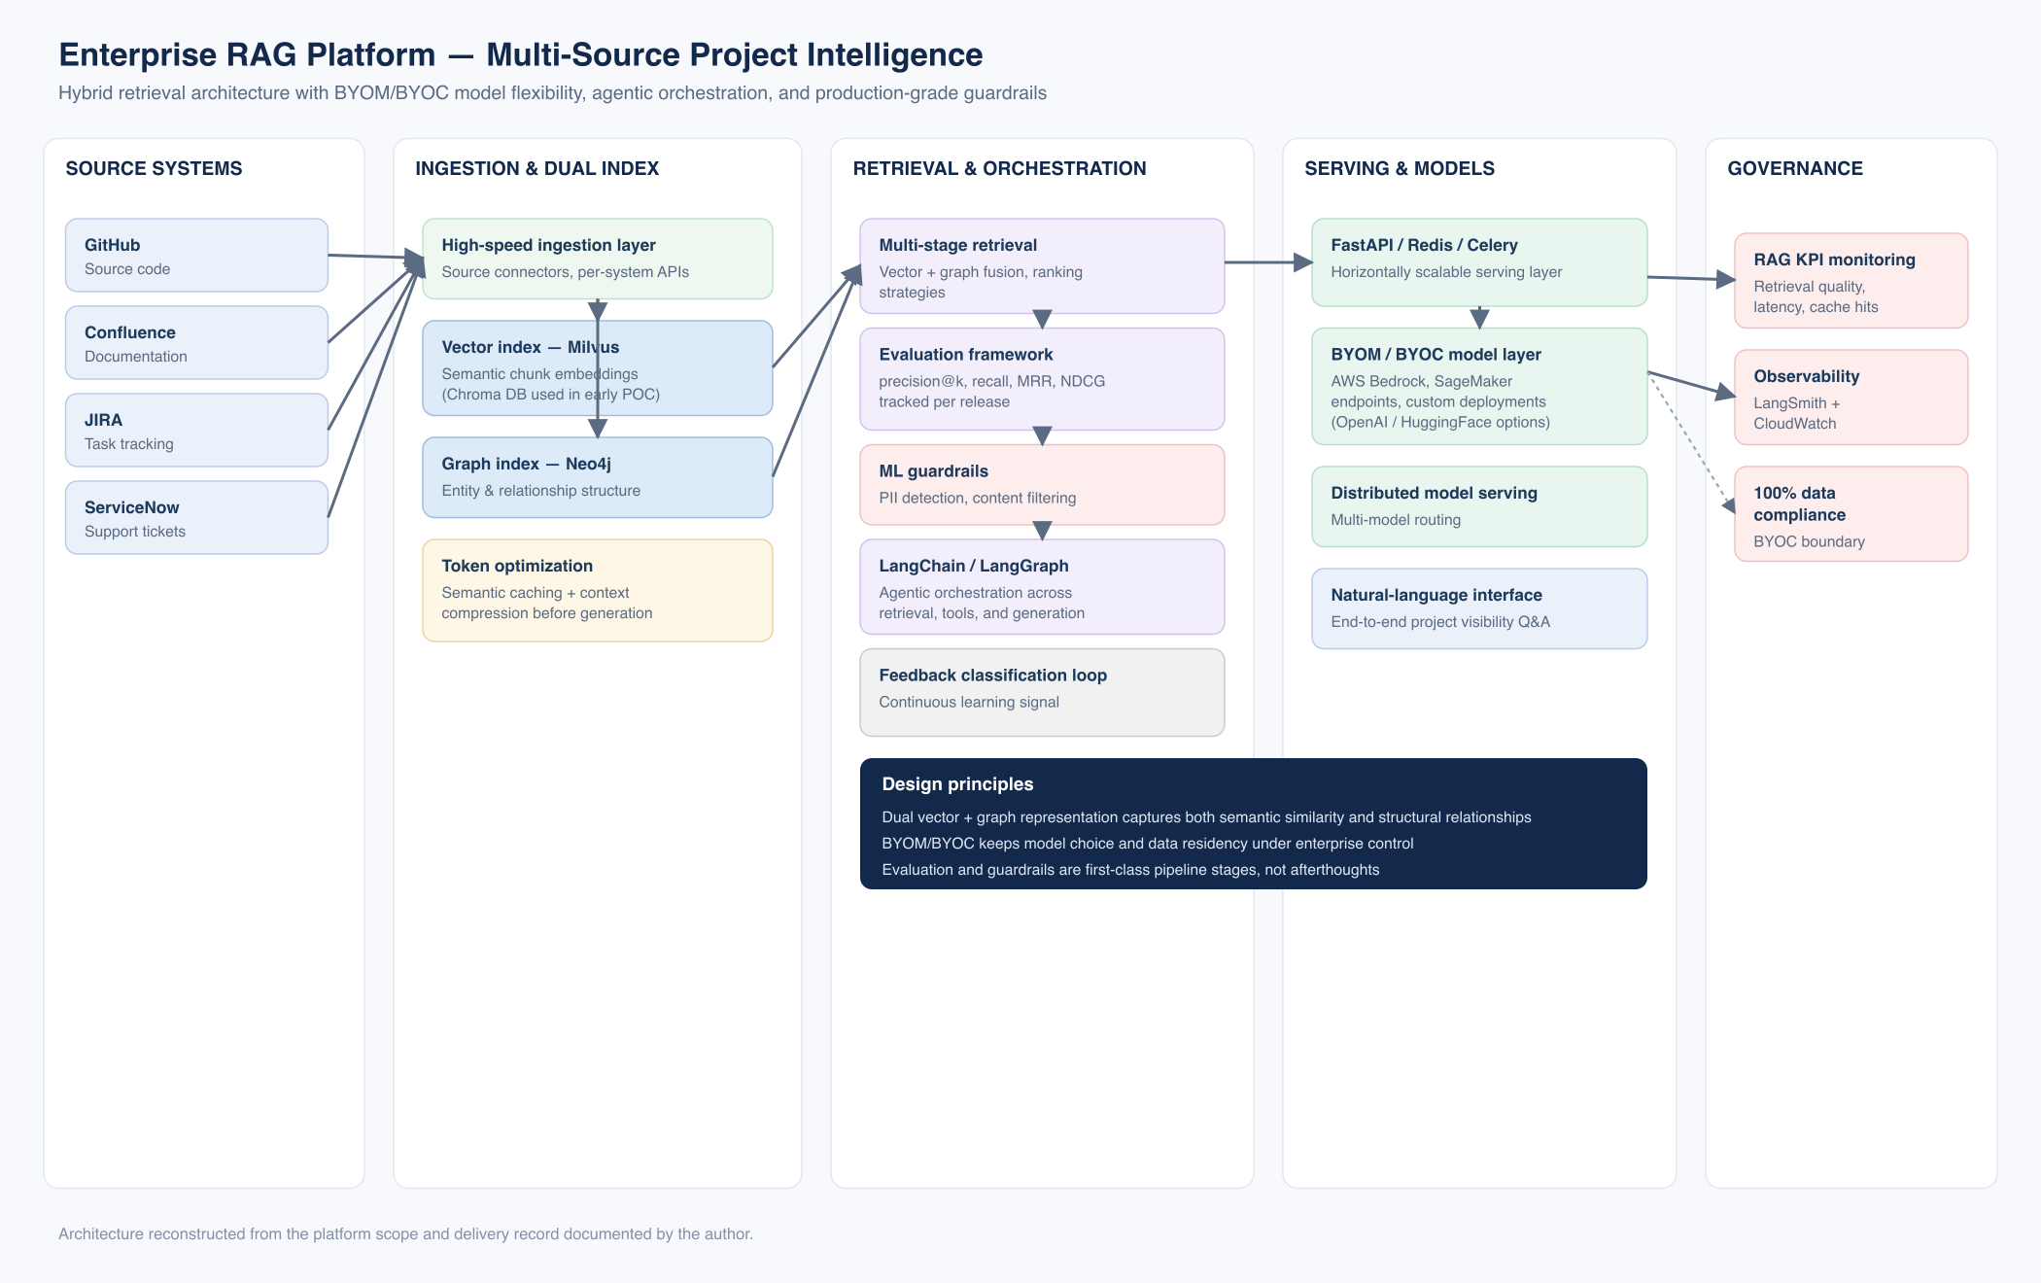
Hybrid retrieval architecture with BYOM/BYOC model flexibility, agentic orchestration, and production-grade guardrails.
Figure — Solution architecture (reconstructed from delivered implementation)
6. MY ROLE & CONTRIBUTIONS
- Architected the BYOM/BYOC enterprise platform, supporting AWS Bedrock, SageMaker endpoints, and custom model deployments so the client could choose model backend and data boundary per use case while holding to a 100% data-compliance requirement.
- Designed the hybrid RAG system with a high-speed ingestion path processing source code, documentation, and tickets into dual representations: a vector index (Milvus in production; Chroma DB during early proof-of-concept) for semantic retrieval, and a graph index (Neo4j) for structural/relationship retrieval.
- Engineered the multi-stage retrieval pipeline and its evaluation framework, tracking precision@k, recall, MRR, and NDCG so retrieval quality could be measured and regressions caught before reaching users.
- Built ML-powered guardrails for PII detection and content filtering, applied before content reaches the retrieval index and before generated answers reach the user.
- Built the horizontally scalable, multi-layer serving architecture: a FastAPI/Redis/Celery serving layer in front of LangChain/LangGraph agentic orchestration, backed by distributed model serving across the BYOM/BYOC backends.
- Implemented token-cost optimization through semantic caching and context compression, with RAG-specific KPI monitoring (retrieval quality, latency, cache-hit rate) so cost and performance stayed visible as usage scaled.
- Integrated a continuous-learning feedback loop via a feedback-classification model, with observability wired through LangSmith and CloudWatch.
7. TECHNOLOGY STACK
Python ● FastAPI ● Celery ● Redis ● Milvus ● Neo4j ● LangChain ● LangGraph ● AWS Bedrock ● AWS SageMaker ● OpenAI / HuggingFace (model options) ● LangSmith ● Amazon CloudWatch
8. IMPLEMENTATION APPROACH
The ingestion and dual-index foundation (vector + graph) was built first against a representative subset of source systems. The retrieval and evaluation framework was built and tuned before agentic orchestration was layered on top, and guardrails and observability were treated as first-class pipeline stages from the outset rather than bolted on after a working prototype. The BYOM/BYOC model layer was designed to be swapped per deployment without touching the retrieval or serving layers.
9. KEY CHALLENGES & HOW THEY WERE ADDRESSED
- Four disparate content types, one retrieval layer — addressed with per-source ingestion connectors feeding a common dual vector + graph indexing stage.
- Semantic vs. structural retrieval — addressed with a dual-index design (Milvus for semantic similarity, Neo4j for relationship/structure), fused at query time by the multi-stage retrieval and ranking layer.
- BYOM/BYOC without forking the platform — addressed with a distinct model-serving layer (Bedrock/SageMaker/custom) fully decoupled from retrieval and serving, so backend swaps don't touch the rest of the architecture.
- Trusting retrieval quality in production — addressed with a dedicated evaluation framework (precision@k, recall, MRR, NDCG) run continuously, not just at launch.
- PII/content risk — addressed with ML guardrails applied at both the ingestion and generation boundaries.
- Cost/latency at scale — addressed with semantic caching and context compression, plus RAG-specific KPI monitoring to keep both visible and controllable.
10. BUSINESS & TECHNICAL OUTCOMES
- A single natural-language interface giving end-to-end project visibility across four previously disconnected systems (GitHub, Confluence, JIRA, ServiceNow).
- 100% data-compliance maintained across BYOM/BYOC deployment options, without forking the platform per backend.
- A production evaluation framework (precision@k, recall, MRR, NDCG) giving retrieval quality a measurable, trackable baseline rather than a one-time demo impression.
- ML-powered PII detection and content-filtering guardrails applied at both ingestion and generation.
- RAG-specific KPI monitoring (retrieval quality, latency, cache-hit rate) plus LangSmith/CloudWatch observability giving the platform production-grade visibility.
11. KEY TAKEAWAYS
- Dual vector + graph indexing captures relationships a pure-semantic retrieval layer misses entirely.
- Decoupling the model-serving layer from retrieval and serving is what makes BYOM/BYOC practical rather than a maintenance burden.
- Evaluation and guardrails belong in the pipeline from day one — retrofitting them after users are relying on the system is a much harder conversation.

