CLIENT ENGAGEMENT

Consolidating Global SAP Supply Chain Data on an Event-Driven Databricks Lakehouse
Global Manufacturing & Distribution · AWS Databricks Lakehouse · Multi-Region SAP Harmonization
Focus areas: Data Architecture · Data Engineering · Cloud · AWS · Databricks · Data Modeling · ETL/ELT · Analytics · Scalability

1. EXECUTIVE SUMMARY
I architected a unified, cloud-based AWS Databricks Lakehouse that consolidates SAP data from multiple global markets into a single certified analytics platform, giving demand planning, inventory, supplier, and logistics teams a governed, real-time view they previously had to piece together market by market.
2. CLIENT CONTEXT (ANONYMIZED)
The client is a multinational manufacturing and distribution enterprise operating SAP ECC, SAP HANA, and SAP S/4HANA concurrently across multiple global regions — with an active HANA-to-S/4 migration in flight — serving over 2,000 daily users across demand planning, inventory, supplier operations, and logistics functions.
3. BUSINESS CHALLENGE
Supply chain data was fragmented by both market and SAP generation, so there was no single, trustworthy view of inventory performance, order fulfillment, or supplier reliability at a global level. Every cross-region analysis required manual reconciliation, and the organization lacked the governance and cost controls needed to scale a growing data platform sustainably.
4. TECHNICAL CHALLENGES
- Harmonizing three structurally different SAP generations — ECC, HANA, and S/4, each with its own schema conventions — into one canonical enterprise data model without losing region-specific business meaning.
- Ingesting only newly arrived SAP delta files with exactly-once guarantees, across many regions landing files independently and asynchronously.
- Applying CDC-style incremental updates, not full reloads, at a scale where full reprocessing would be operationally and financially unsustainable.
- Balancing centralized governance (one certified Gold layer) against decentralized domain-level analytics ownership, so regional and domain teams could move independently without re-fragmenting the platform.
- Building data-quality and cost observability into the platform from the start, given the absence of an existing enterprise-wide data lifecycle or retention policy driving unnecessary hot-storage cost growth.
5. SOLUTION / ARCHITECTURE
The platform uses a Bronze/Silver/Gold medallion design on Delta Lake. Ingestion is event-driven end to end: an S3 PUT notification fires on every new SAP delta file, routed through EventBridge to trigger Databricks Auto Loader, which processes only newly arrived files with exactly-once guarantees. Incremental CDC pipelines built on Delta Lake `MERGE` harmonize SAP ECC, HANA, and S/4 data into canonical Silver models, which feed certified Gold-layer business models — inventory turnover, OTIF, lead-time variance, forecast accuracy, and supplier performance. Governance follows a hub-and-spoke model: centralized ingestion and certified Gold contracts in a hub workspace, with decentralized, domain-level analytics and data marts running in spoke workspaces.
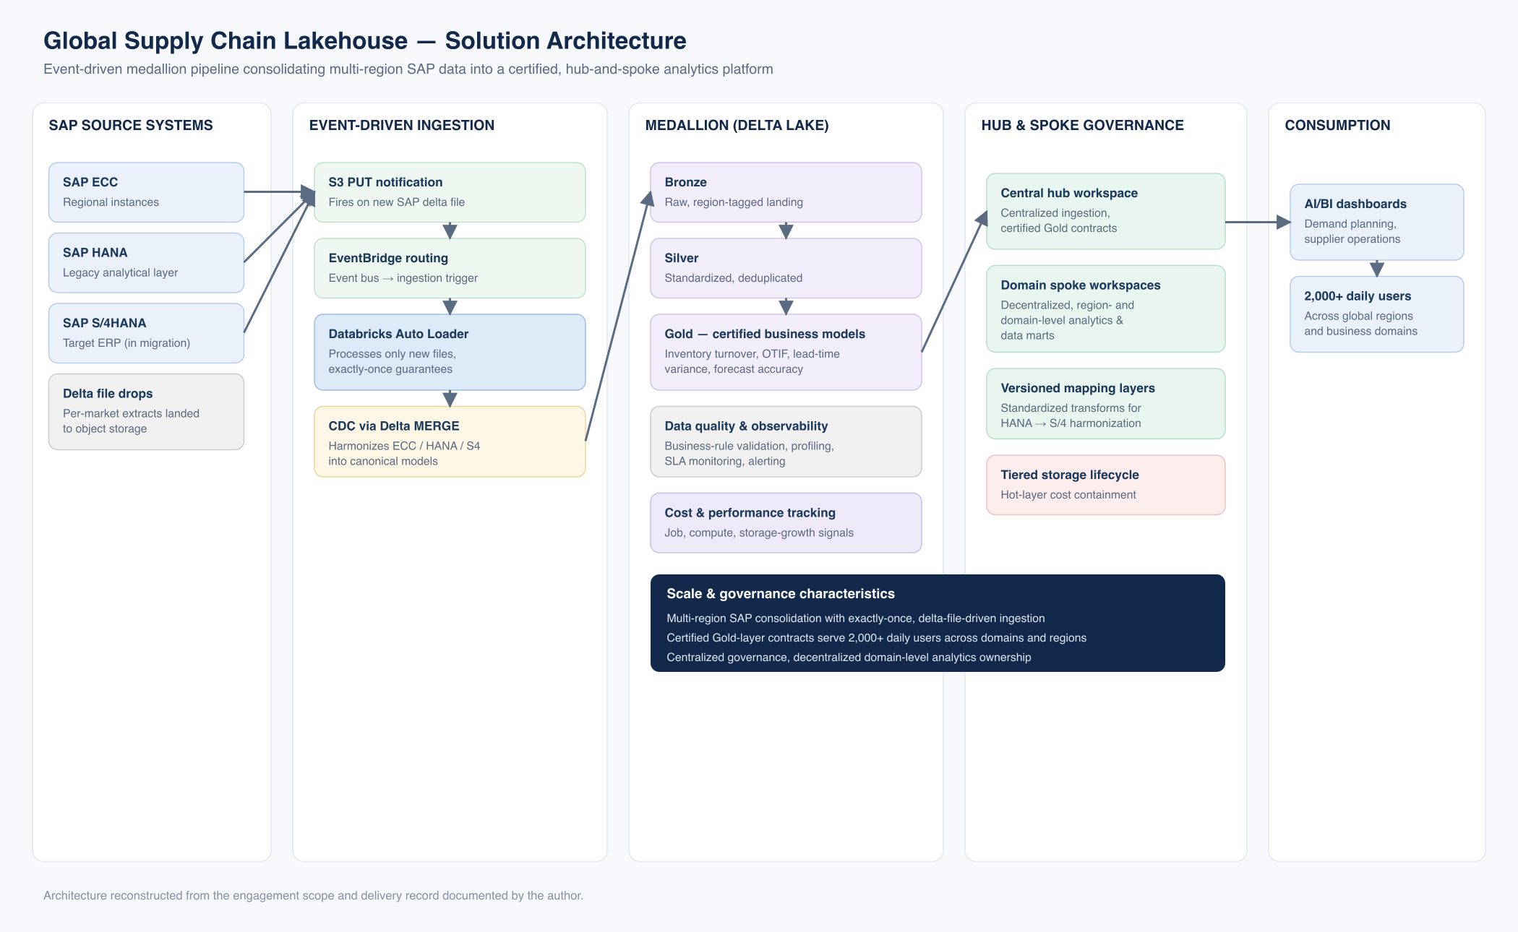
Event-driven medallion pipeline consolidating multi-region SAP data into a certified, hub-and-spoke analytics platform.
Figure — Solution architecture (reconstructed from delivered implementation)
6. MY ROLE & CONTRIBUTIONS
- Architected the AWS Databricks Lakehouse using a Bronze–Silver–Gold medallion design to ingest, standardize, and certify supply chain datasets across multiple global regions.
- Designed the event-driven ingestion framework — S3 PUT notifications through EventBridge triggering Databricks Auto Loader — so only newly arrived SAP delta files are processed, with exactly-once guarantees, instead of scheduled full-directory scans.
- Engineered the incremental CDC pipelines using Delta Lake `MERGE` patterns that harmonize SAP ECC, HANA, and S/4 data into canonical enterprise data models.
- Implemented a hub-and-spoke platform architecture: centralized ingestion and governance in a hub workspace, with decentralized, domain-level analytics and data marts running in spoke Databricks workspaces.
- Built the certified Gold-layer business models — inventory turnover, OTIF, lead-time variance, forecast accuracy, and supplier performance — consumed by 2,000+ daily users.
- Developed the data-quality and observability framework: business-rule validation, automated profiling, SLA monitoring, and alerting surfaced through AI/BI dashboards.
- Built a continuous optimization system tracking job performance, compute utilization, and storage growth to improve pipeline efficiency and cost transparency.
- Designed the standardized transformation and versioned mapping-layer framework used to absorb the ongoing SAP HANA → S/4 migration without breaking downstream Gold models.
- Proposed and scoped a data lifecycle / tiered-storage strategy to control hot-layer storage cost growth in the absence of an enterprise-wide retention policy.
7. TECHNOLOGY STACK
AWS ● Databricks (Delta Lake, Unity Catalog, Structured Streaming, Auto Loader, MLflow) ● Apache Kafka ● PySpark ● SQL ● Amazon S3 ● Amazon EventBridge ● AI/BI dashboarding
8. IMPLEMENTATION APPROACH
Bronze ingestion and the event-driven trigger chain were stood up first, per region, followed by canonical Silver harmonization models built incrementally as each SAP generation's mapping was validated. Gold business models were certified once Silver was stable, with the hub-and-spoke governance model and the cost/observability tooling layered in as the platform scaled from a single-region pilot to multi-region production.
9. KEY CHALLENGES & HOW THEY WERE ADDRESSED
- Three SAP generations, one model — addressed with versioned, standardized transformation and mapping layers that isolate each generation's quirks from the canonical Gold schema.
- Exactly-once ingestion at multi-region scale — addressed with the S3 PUT → EventBridge → Auto Loader event-driven chain, replacing polling or scheduled full scans.
- Governance vs. domain autonomy — addressed with the hub-and-spoke workspace model: one governed Gold contract, many independently operated spoke workspaces.
- Unsustainable full reprocessing — addressed with Delta Lake `MERGE`-based CDC instead of full reloads.
- Uncontrolled storage cost growth — addressed with a proposed tiered-storage/lifecycle policy plus a continuous compute/storage cost-tracking system.
10. BUSINESS & TECHNICAL OUTCOMES
- Certified Gold-layer business models (inventory turnover, OTIF, lead-time variance, forecast accuracy, supplier performance) consumed by 2,000+ daily users across regions and functions.
- Exactly-once, event-driven ingestion replacing scheduled or polling-based extraction across multiple global markets.
- A hub-and-spoke governance model that scales to new regions and domains without re-centralizing every analytics decision.
- A cost and performance observability layer giving the platform visibility into job, compute, and storage growth it did not previously have.
- A repeatable transformation and mapping framework absorbing the in-flight SAP HANA → S/4 migration without breaking existing Gold consumers.
11. KEY TAKEAWAYS
- Event-driven ingestion (file-notification-triggered) scales more predictably across regions than scheduled polling.
- Hub-and-spoke governance lets a platform grow by domain without every new team becoming a bottleneck on the central team.
- Cost observability has to be designed in alongside the pipeline — it's far harder to retrofit once storage growth is already uncontrolled.

