CLIENT ENGAGEMENT

Field-Level PII/PCI Tokenization for a Kafka-to-Snowflake Streaming Pipeline
Veterinary Healthcare & Pharmacy Services · GCP Managed Kafka + Cloud DLP · Real-Time Data Security
Focus areas: Streaming · Kafka · Data Governance · Cloud · Snowflake · Data Engineering · Performance Optimization · Scalability

1. EXECUTIVE SUMMARY
I designed and built StreamShield, a production-grade Python SDK and reference pipeline that tokenizes PII/PCI fields before they ever enter Kafka, enforces schema at the wire, and delivers events into Snowflake in under two minutes end-to-end — replacing a SaaS-connector approach that had no architecturally sound place to inject tokenization before data left the source.
2. CLIENT CONTEXT (ANONYMIZED)
The client is a veterinary pharmacy and prescription-fulfillment platform serving thousands of veterinary practices (9,000+) across the country, generating tens of millions of order- and prescription-related events per month that needed to reach Snowflake for downstream analytics and operations.
3. BUSINESS CHALLENGE
The client needed near-real-time (sub-2-minute) visibility into order and prescription events in Snowflake, at a monthly event volume where a per-row-priced managed connector was not commercially viable, while being contractually and architecturally required to never let raw PII (owner names, emails, phone numbers, payment details, pet and prescription details) transit any system in plaintext — a guarantee a managed SaaS connector could not structurally provide, since its only tokenization point is a post-load Snowflake transformation, by which point the data has already transited the vendor's infrastructure unprotected.
4. TECHNICAL CHALLENGES
- Tokenizing sensitive fields before publish without adding unacceptable per-message latency or per-record API cost.
- Supporting multiple tokenization methods within one framework — reversible deterministic encryption for lookups, irreversible hashing for fields that never need to be un-tokenized, and format-preserving encryption for payment card numbers that must retain their shape.
- Keeping the tokenization policy itself out of application code, so every producer and consumer team inherits the same protection rules without per-team DLP configuration.
- Preventing silent credential and schema drift in a long-running streaming process — expiring OAuth tokens, evolving event schemas — without requiring redeploys.
- Guaranteeing no message is silently lost on a downstream failure, while keeping common-case latency low.
- Providing a controlled, fully audited way for authorized users to re-identify tokenized data, without weakening the "no plaintext in the pipeline" guarantee.
5. SOLUTION / ARCHITECTURE
Every `producer.send()` call runs through a fixed sequence: an ADC token freshness check and cached schema lookup, local schema validation (failing fast before any network or DLP call), field-level DLP tokenization driven entirely by policy embedded in the Avro schema, Avro serialization in Confluent wire format, and a manually-committed produce/flush to a GCP Managed Kafka cluster. From there, Managed Kafka Connect's GCS Sink Connector decodes and batches records to Cloud Storage every 60 seconds; a Cloud Storage object-finalize event triggers Pub/Sub, which drives Snowflake's Snowpipe auto-ingest — an event-driven chain with no polling loop anywhere in the path.
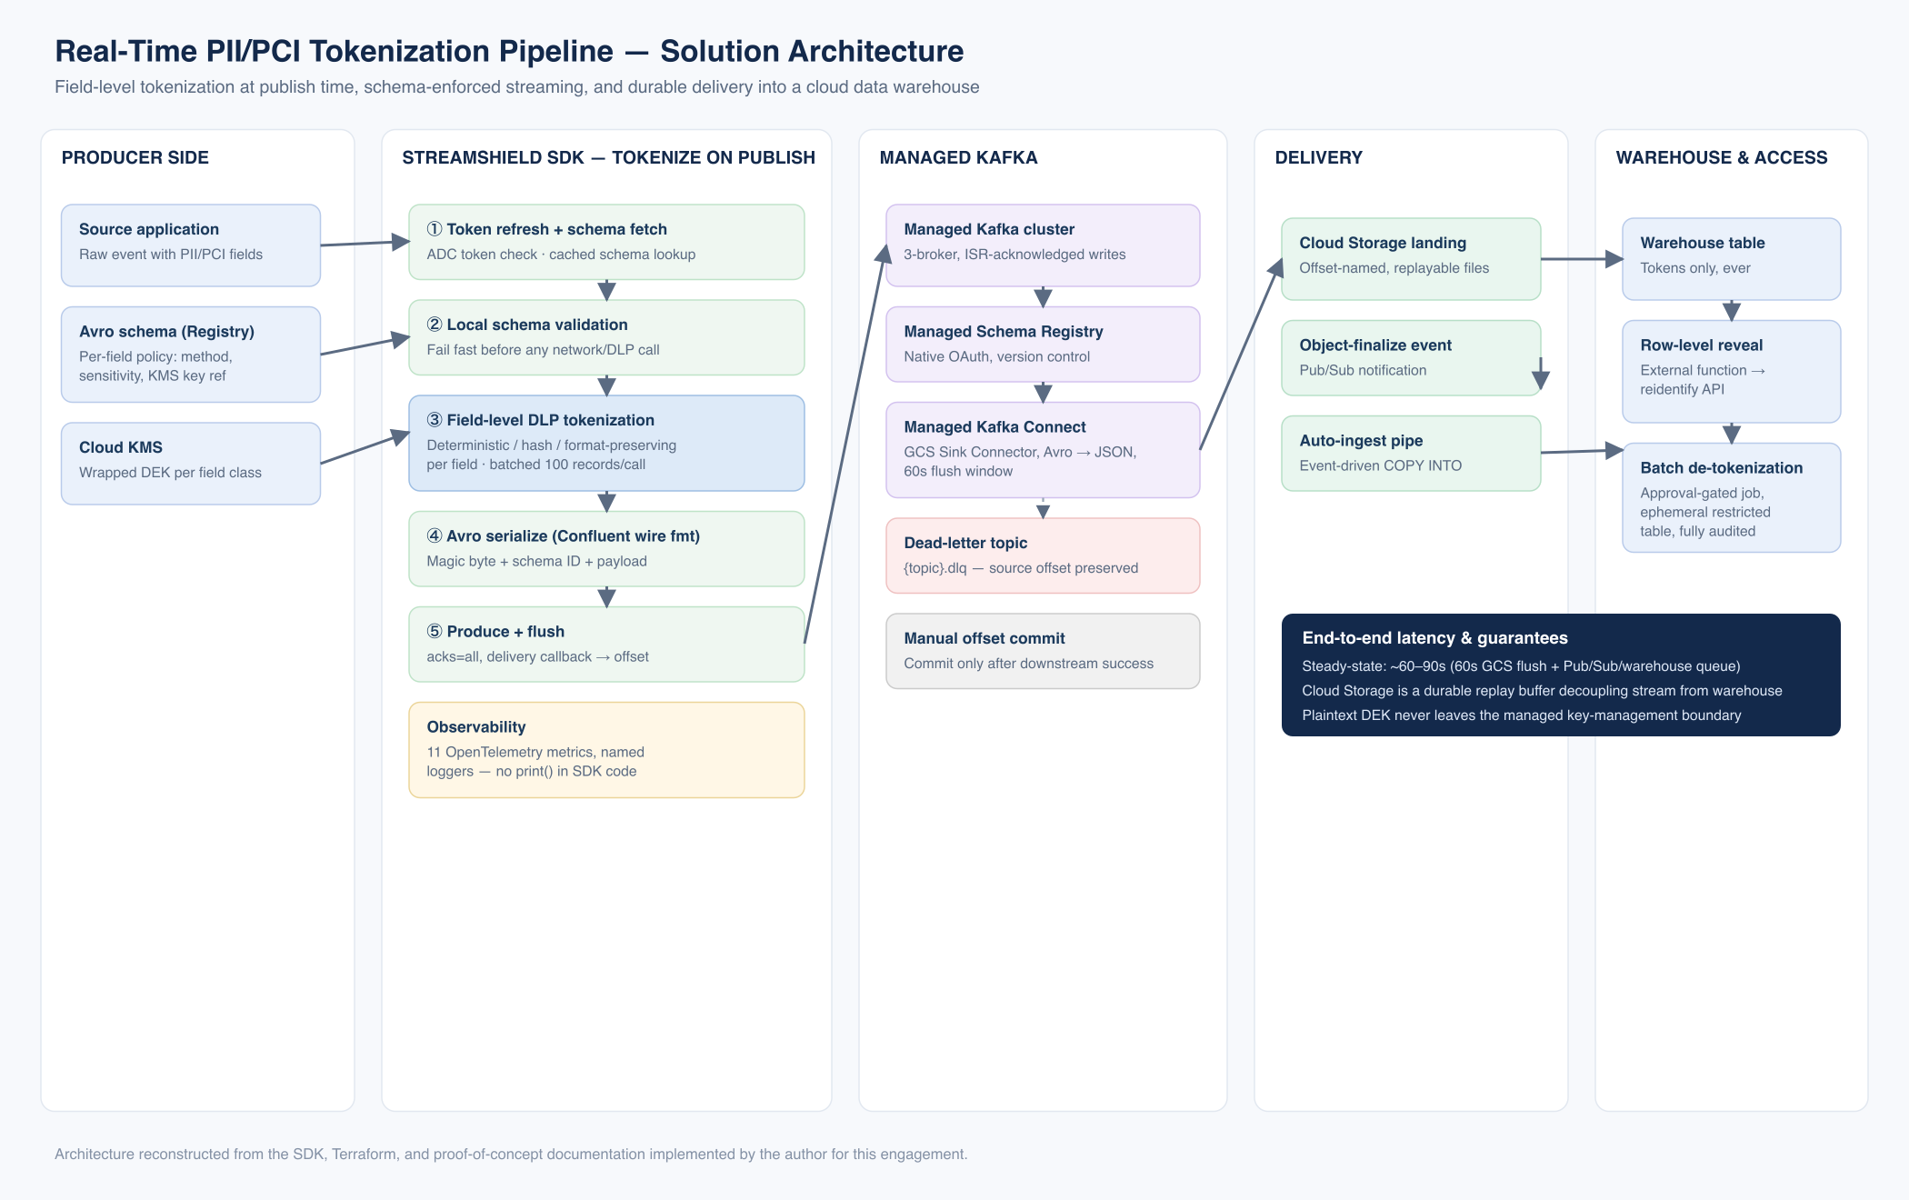
Field-level tokenization at publish time, schema-enforced streaming, and durable delivery into a cloud data warehouse.
Figure — Solution architecture (reconstructed from delivered implementation)
6. MY ROLE & CONTRIBUTIONS
- Designed and built the StreamShield Python SDK end-to-end: producer/consumer facade, schema/topic admin, and the DLP tokenization layer (tokenizer, detokenizer, policy engine, token cache).
- Designed the schema-driven policy model where each Avro field carries its own tokenization method, sensitivity class, and KMS key reference as schema metadata, so protection policy travels with the schema instead of living in application code.
- Implemented the batched DLP call pattern (100 records per API call instead of one), cutting per-record DLP cost by roughly two orders of magnitude versus the initial proof-of-concept approach.
- Built the token-refresh safeguard that proactively renews the application-default-credential token five minutes before expiry, so long-running producer/consumer processes never silently fail on auth.
- Implemented hard `enable.auto.commit=False` offset handling with commit only after a successful downstream write, plus the `{topic}.dlq` dead-letter routing design for the next phase of failure handling.
- Instrumented the SDK with 11 OpenTelemetry metrics and structured, named logging (no ad hoc `print()` calls) for production observability.
- Ran the architecture proof-of-concept that selected GCP Managed Schema Registry over Confluent Cloud (native OAuth, fewer secrets to manage) and Managed Kafka Connect's GCS Sink Connector over a custom Dataflow job (no custom pipeline code to operate, sub-60-second Snowpipe auto-ingest latency) — including writing the documented rationale against the Fivetran alternative.
- Authored the Terraform modules (VPC, IAM, Managed Kafka, GCS, Pub/Sub, Secret Manager) that let the full environment be reproduced in a new GCP project from a single `terraform apply`.
- Wrote the full architecture-decision-record set and step-by-step GCP setup guides used to hand the proof-of-concept off to the wider engineering team.
- Delivered 63 automated tests (50 unit, 13 integration) covering the SDK before the first production rollout.
7. TECHNOLOGY STACK
Python ● GCP Managed Kafka ● Confluent wire format / Avro ● GCP Managed Schema Registry ● Google Cloud DLP ● Google Cloud KMS ● Managed Kafka Connect (GCS Sink) ● Google Cloud Storage ● Google Cloud Pub/Sub ● Snowflake (Snowpipe) ● Terraform ● OpenTelemetry
8. IMPLEMENTATION APPROACH
The proof-of-concept phase validated the architecture manually — documented as a set of architecture-decision records — before any SDK code was written, so the SDK packages already-proven patterns rather than being designed speculatively. Dead-letter-queue handling and de-tokenization access controls were explicitly sequenced as phase-2 work rather than blocking the phase-1 ingestion-and-security launch, keeping the initial rollout scoped to what the business needed first: PII never in plaintext, and data flowing end-to-end within the latency target.
9. KEY CHALLENGES & HOW THEY WERE ADDRESSED
- Latency vs. cost trade-off — addressed with batched DLP calls (100 records/call) plus an event-driven, not polling, GCS → Pub/Sub → Snowpipe chain, landing steady-state end-to-end latency around 60–90 seconds.
- Multiple tokenization needs in one framework — addressed with per-field schema metadata selecting deterministic, hash, or format-preserving encryption per field, resolved once per schema version and cached.
- Policy drift across teams — addressed by keeping policy in the versioned schema rather than each producer's code, so every consumer of that schema automatically inherits the same protection.
- Long-running credential/schema drift — addressed with proactive token refresh and schema-registry caching, with fail-fast local validation before any network call.
- No silent message loss — addressed with manual offset commits only after confirmed downstream success, plus a dead-letter-topic design for the failure path.
- Controlled re-identification — addressed with two explicitly separate access patterns: a low-volume row-level lookup via a Snowflake external function, and a high-volume batch de-tokenization via an approval-gated job — both fully logged and kept entirely outside the streaming pipeline itself.
10. BUSINESS & TECHNICAL OUTCOMES
- A structural guarantee that raw PII/PCI never transits Kafka, Cloud Storage, or Snowflake in plaintext — every downstream system holds tokens only.
- Steady-state end-to-end latency of roughly 60–90 seconds from event publish to a queryable Snowflake row, against a sub-2-minute target.
- Avoided per-row SaaS-connector pricing at the client's event volume (9,000+ practices, tens of millions of events/month) by using managed open infrastructure instead.
- 63 passing automated tests (50 unit, 13 integration) at SDK handoff.
- A reusable, documented Terraform-based environment reproducible in a new GCP project without manual setup.
11. KEY TAKEAWAYS
- Tokenize at the source, not post-load — the guarantee is only structural if plaintext never leaves the producer.
- Schema-embedded policy scales protection across teams without per-team configuration burden.
- An event-driven delivery chain (no polling) is both lower-latency and operationally simpler than the alternative.

