CLIENT ENGAGEMENT

Identity Synchronization and Service-Principal Risk Analytics on Databricks
Diversified Industrial & Technology Manufacturing · Databricks Unity Catalog · Cloud Identity Governance
Focus areas: Data Governance · Data Architecture · Databricks · Cloud · AWS · Analytics · Data Modeling

1. EXECUTIVE SUMMARY
I built two connected identity-governance capabilities on Databricks for a global technology manufacturer: a production IAM synchronization job that keeps Unity Catalog's user/role/persona model current from the enterprise identity source, and a daily service-principal (SPN) fleet risk-analytics pipeline and dashboard giving the security team a single, scored view of every non-human identity's privilege and activity posture across the workspace.
2. CLIENT CONTEXT (ANONYMIZED)
The client is a global, diversified industrial and technology manufacturer operating across multiple business segments (including industrial and transportation) and environments (dev/qa/prod), with a large Databricks estate governed under Unity Catalog and a growing population of service principals provisioned automatically via enterprise identity federation.
3. BUSINESS CHALLENGE
Two related but distinct governance gaps existed. First, the enterprise IAM system of record wasn't reliably reflected inside Unity Catalog, so role- and persona-based access decisions inside Databricks risked drifting from the approved enterprise state. Second, the platform had no consolidated inventory of its service principals — which held admin privileges, which were dormant, which had been granted access directly instead of through governed groups — leaving the security team unable to answer a basic question: which non-human identities represent the biggest exposure right now?
4. TECHNICAL CHALLENGES
- Synchronizing role, persona, and service-account state from an external PostgreSQL system of record into four interdependent Unity Catalog Delta tables without full-table rewrites on every run.
- Correctly masking and re-linking service-account identities — which follow a distinct naming convention — so they don't pollute the human-user persona registry, while keeping their access fully auditable.
- Enforcing business-unit-scoped access rules that apply only conditionally (only when a restriction flag is set and the segment isn't global) inside a single shared transformation.
- No native "SPN created" audit event exists in the platform — service principals arrive via enterprise identity federation, not a Databricks-native provisioning flow — so activity and ownership had to be reconstructed from indirect signals.
- The platform's job-run audit trail records identity by an opaque federated-identity GUID rather than the SPN's display name, so activity couldn't be attributed without a separate mapping step.
- Defining a risk model precise enough to be actionable — not just "everything is medium risk" — from privilege, group-membership, and activity signals that each say something different about exposure.
5. SOLUTION / ARCHITECTURE
The IAM sync job reads applied roles, user profiles, and business-segment data from PostgreSQL, applies transformation and service-account masking logic, and merge-upserts the result into four Unity Catalog Delta tables, scoped per environment (dev/qa/prod catalogs). Independently, a four-notebook SPN Fleet Management pipeline builds a daily, snapshot-partitioned inventory: SPN roster and risk tier, a full Unity Catalog privilege map (direct and inherited grants), and a 30/90-day activity summary joined via a dedicated GUID-to-display-name mapping table. A weighted risk-tier waterfall and a separate five-signal anomaly-scoring model feed a Databricks Lakeview dashboard used directly by the security and platform teams.
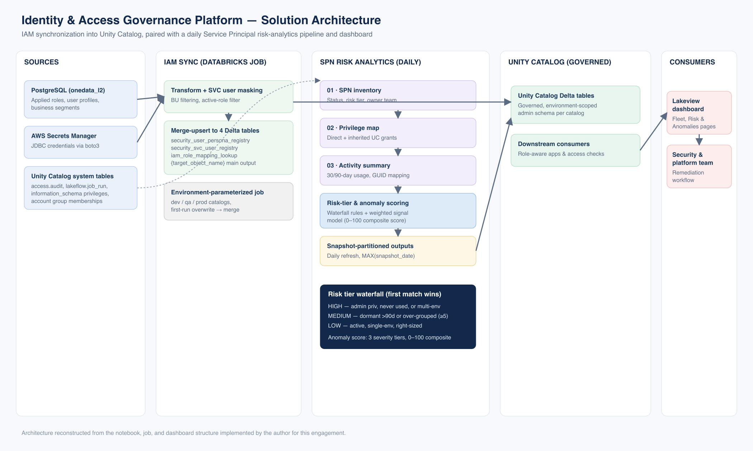
IAM synchronization into Unity Catalog, paired with a daily Service Principal risk-analytics pipeline and dashboard.
Figure — Solution architecture (reconstructed from delivered implementation)
6. MY ROLE & CONTRIBUTIONS
- Designed and built the parameterized Databricks IAM synchronization job that reads applied roles, user profiles, and business-segment data from PostgreSQL and merge-upserts it into four Unity Catalog Delta tables, environment-scoped across dev/qa/prod catalogs.
- Implemented the service-account masking logic (renaming and email-blanking pattern-matched SVC accounts, recoverable via a join back to a dedicated SVC registry table) so human and non-human identities stay correctly separated in the persona model.
- Built the conditional business-unit access-restriction logic and the active-role/approver-role filtering rules determining which role assignments are considered "in force."
- Designed the four-notebook SPN Fleet Management pipeline (inventory → privilege map → activity summary → planned sensitivity enrichment) from the ground up, including the GUID-to-display-name mapping table that solves the federated-identity attribution gap.
- Authored the full risk-tier waterfall (HIGH/MEDIUM/LOW) and the five-signal, three-tier weighted anomaly-scoring model (0–100 composite) flagging orphaned-and-privileged, dormant-admin, direct-grant, multi-environment, and privilege/usage-gap identities.
- Designed the owner-team attribution logic (group-prefix mapping with a thirteen-level priority score for SPNs in multiple groups) and the naming-convention-based application-purpose classifier.
- Built the Databricks Lakeview dashboard (SPN Fleet, Risk & Anomalies, and FAQ/Methodology pages) consumed directly by the security and platform teams, plus the parameterized SPN Deep Dive dataset.
- Wrote the full methodology reference documentation — classification rules, scoring logic, remediation workflow — used to onboard the security team onto the dashboard.
7. TECHNOLOGY STACK
Databricks (SQL notebooks, Lakeview dashboards) ● Unity Catalog ● Delta Lake ● PySpark ● PostgreSQL (JDBC) ● AWS Secrets Manager (boto3) ● Unity Catalog system tables
8. IMPLEMENTATION APPROACH
Build order followed the data dependency chain: IAM sync first, then SPN inventory, then the privilege map, then the activity summary (joined against the GUID map), then risk-tier and anomaly scoring, then the dashboard. All SPN pipeline outputs are snapshot-partitioned by date and designed to run as an unattended scheduled daily workflow, with the dashboard always reading the latest snapshot.
9. KEY CHALLENGES & HOW THEY WERE ADDRESSED
- No native SPN creation event — addressed by using the first `addPrincipalToGroup` event as a documented, transparent proxy for onboarding date.
- Federated-identity GUID vs. display name — addressed with a dedicated `guid_map` table built from audit identity metadata, joined into every downstream activity table.
- Actionable, not flat, risk scoring — addressed with two complementary models: a waterfall risk tier answering governance policy ("what category is this SPN"), and a separate additive anomaly score answering operational priority ("where should the security team look first today").
- Conditional BU-access rules — addressed by encoding them as explicit filter conditions tied to the `restrict_bu_access` and `business_segment` fields, rather than hardcoded per-business-unit logic.
- Merge cost at scale — addressed with a first-run overwrite, subsequent-run conditional `DeltaTable.merge()` pattern across all four sync tables, avoiding unnecessary rewrites.
10. BUSINESS & TECHNICAL OUTCOMES
- A single, governed source of truth for user/role/persona state inside Unity Catalog, replacing manual or indirect reconciliation against the enterprise IAM system.
- The first consolidated, scored inventory of the platform's service-principal population, covering privilege, ownership, and activity in one place.
- A documented, explainable remediation workflow (CRITICAL → HIGH → MEDIUM) giving the security team a prioritized queue instead of an undifferentiated identity list.
- Snapshot-partitioned, daily-refreshed outputs designed to run as an unattended scheduled workflow.
- A written FAQ/methodology reference turning every scoring and classification rule into an auditable, onboarding-ready document rather than tribal knowledge.
11. KEY TAKEAWAYS
- Federated, non-human identities need their own attribution infrastructure — audit logs designed around human logins don't map cleanly onto them.
- Separate "governance category" (risk tier) from "operational priority" (anomaly score) — conflating the two produces a model that's either too coarse to act on or too noisy to trust.
- A documented methodology reference is what turns a scoring model into something a security team will actually adopt and defend in an audit.

