CLIENT ENGAGEMENT

Unifying SAP and Salesforce Contract Data on a Governed Databricks Lakehouse
Industrial & Technology Manufacturing · Azure Data Factory + Databricks · Real-Time Contract CDC
Focus areas: Data Architecture · Data Engineering · Cloud · Databricks · Data Governance · Data Modeling · Streaming · Kafka · ETL/ELT

1. EXECUTIVE SUMMARY
I architected and built a production Azure Data Factory + Databricks lakehouse that unifies two parallel service-contract data domains — one rooted in SAP, one in Salesforce — into a governed Bronze/Silver/Gold model, with a real-time Kafka change-data-capture (CDC) path feeding contract and entitlement changes to a downstream Contract API, running on a daily production schedule under SOX-scoped controls.
2. CLIENT CONTEXT (ANONYMIZED)
The client is a global manufacturer of industrial and technology products with an established service-contract and entitlement business spanning multiple product lines, running SAP for core order and contract management alongside Salesforce (Apttus CLM, SMAX, CCRM) for service-contract and entitlement workflows.
3. BUSINESS CHALLENGE
Product service contracts lived in SAP; service contracts and entitlements lived in Salesforce — two systems of record, two data models, and no unified, governed view of what a given customer was entitled to at any point in time. Reporting, SOX audit, and downstream systems needing entitlement data had each built their own point-to-point extracts, so a change to either source system risked silently breaking multiple undocumented downstream dependencies.
4. TECHNICAL CHALLENGES
- Reconciling two structurally different contract data models — SAP's VBAK/VBKD/VBAP/VEDA/VBFA sales-document chain versus Salesforce Apttus/SMAX/CCRM's contract lifecycle objects — into consistent Silver-layer entities without losing either domain's business meaning.
- Delivering near-real-time entitlement visibility to a downstream Contract API without exposing that API directly to either source system.
- Supporting SOX-auditable, repeatable daily runs with full/incremental/Kafka-only replay modes and a historical reprocessing window, so any prior day's contract state is reproducible on demand.
- Guarding a shared Kafka topic against runaway event volume from either domain, so a bad SAP or Salesforce batch can't flood downstream consumers.
- Migrating the platform's governance model from file-path-based Delta access to Unity Catalog without downtime, while old and new code paths had to coexist through the transition.
5. SOLUTION / ARCHITECTURE
The platform runs a Bronze/Silver/Gold medallion design on Azure Data Lake Storage Gen2, orchestrated by Azure Data Factory and executed on Azure Databricks. A main orchestration pipeline triggers conditional sub-pipelines per domain (ZCSP for SAP-rooted product service contracts, ZCSS for Salesforce-rooted service contracts and entitlements) and per processing mode. Silver-layer notebooks implement each domain's specific entity model — contract headers, line items, covered products, entitlements, discount and risk-sharing models — before both domains land in a common, Unity Catalog-governed Gold layer. A five-stage Kafka CDC chain then carries Silver-layer contract changes through to the downstream Contract API and back into a formatted response feed.
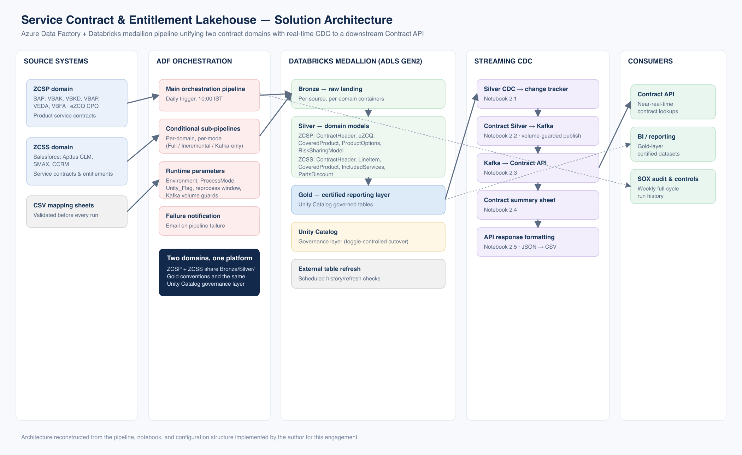
Azure Data Factory + Databricks medallion pipeline unifying two contract domains with real-time CDC to a downstream Contract API.
Figure — Solution architecture (reconstructed from delivered implementation)
6. MY ROLE & CONTRIBUTIONS
- Architected the end-to-end Bronze/Silver/Gold medallion design spanning both the ZCSP and ZCSS domains on Azure Data Lake Storage Gen2.
- Designed and built the Azure Data Factory orchestration layer: one main pipeline triggering conditional sub-pipelines per domain and processing mode (Full / Incremental / Kafka-only), parameterized for environment, reprocessing windows, and validation toggles.
- Built the ten-plus Databricks Silver transformation notebooks (ZCSP-1.0 through 1.5, ZCSS-1.0 through 1.5) implementing the domain-specific business logic for contract headers, line items, covered products, entitlements, and discount/risk-sharing models.
- Designed and implemented the five-stage Kafka CDC chain — from Silver change-tracking through Contract API delivery and response formatting — including the event-volume guard thresholds protecting downstream systems from abnormal batches.
- Led the migration of the shared data-access layer from a legacy file-path-based `DataOperations` class to a Unity Catalog-aware version, toggled per environment so the cutover could be staged domain-by-domain rather than as a single high-risk event.
- Built the CSV mapping-sheet validation gate that runs before every pipeline execution, and the automated email notification on pipeline failure/completion.
- Established the notebook and pipeline naming/parameter conventions (`DOMAIN-STEP.Description.py`, environment/mode parameters) that the wider engineering team now follows for new development.
7. TECHNOLOGY STACK
Azure Data Factory ● Azure Databricks ● Azure Data Lake Storage Gen2 ● Delta Lake ● Unity Catalog ● Apache Kafka ● PySpark ● SAP (VBAK/VBKD/VBAP/VEDA/VBFA) ● Salesforce (Apttus CLM, SMAX, CCRM) ● eZCQ CPQ
8. IMPLEMENTATION APPROACH
Delivery was phased: Bronze ingestion and mapping-sheet validation went live first, followed by Silver-layer domain logic built out entity by entity, then Gold-layer certification under Unity Catalog governance. The Kafka CDC path was layered on top only once the batch foundation was stable, at which point the pipeline moved to its current daily production cadence — triggered at 10:00 IST every day of the week — to keep entitlement data continuously current for SOX audit purposes.
9. KEY CHALLENGES & HOW THEY WERE ADDRESSED
- Two contract data models — addressed with per-domain Silver notebook sets (ZCSP/ZCSS) sharing common Bronze/Gold conventions and a shared data-access utility layer, so downstream Gold consumers see one consistent shape regardless of source system.
- Real-time delivery without direct source exposure — addressed by decoupling the Contract API from SAP/Salesforce entirely via Kafka: the API only ever reads from the CDC topic.
- SOX-auditable repeatability — addressed with explicit `ProcessMode` (Full/Incremental/Kafka-only) and `Reprocess_date` parameters, making every run's exact scope explicit and re-runnable on demand.
- Runaway event volume — addressed with `CreationThreshold`/`UpdateThreshold` guard parameters that halt Kafka publication if a batch looks abnormal, rather than silently flooding the Contract API.
- Zero-downtime governance migration — addressed with a `Unity_Flag` toggle letting Unity Catalog cut over per environment and per domain instead of requiring a single big-bang migration.
10. BUSINESS & TECHNICAL OUTCOMES
- A single governed Gold layer replacing what were previously siloed, source-specific extracts for product and service contract data.
- A daily automated run cadence (every day of the week, 10:00 IST) replacing manual, ad hoc reconciliation between the SAP and Salesforce domains.
- Near-real-time entitlement visibility delivered to the downstream Contract API via the Kafka CDC path, in addition to batch visibility.
- A SOX-auditable run history with explicit reprocessing controls, supporting the client's compliance and audit requirements.
- A reusable, parameter-toggled Unity Catalog migration pattern that let the platform move by domain and environment rather than requiring a single high-risk cutover event.
11. KEY TAKEAWAYS
- Unify divergent source systems behind one governed layer without erasing each domain's specific business meaning.
- Decouple real-time delivery via CDC/Kafka rather than building point-to-point API integrations against source systems.
- Parameterize for auditability from day one — reprocessing windows and explicit run modes are far cheaper to design in than to retrofit.
- Stage governance migrations behind feature flags so a platform-wide cutover doesn't have to be a single high-risk event.

