ILLUSTRATIVE REFERENCE SCENARIO
This case study is based on a publicly documented industry implementation pattern. It is not a client engagement of the author and does not represent proprietary client data. It is presented here to illustrate the author's architectural approach to a comparable problem.

Grid-Scale Distributed Energy Load Forecasting at Daily Cadence
Utilities & Energy · Azure Databricks · Ensemble Time-Series Forecasting at Scale
Focus areas: Data Engineering · Cloud · Databricks · Streaming · AI/ML · Performance Optimization · Scalability

1. EXECUTIVE SUMMARY
Electricity distribution system operators (DSOs) plan grid capacity around large static safety margins for low-probability peak events — a conservative approach that caps how much new generation can be connected using existing infrastructure. Reliable, near-term load forecasts at the individual installation level let planners run power-flow analysis and unlock hosting-capacity headroom without new physical build-out. This case study is an illustrative reference scenario, modeled on a publicly documented large-scale Azure Databricks forecasting implementation for a European electricity distribution network, that I use to demonstrate how I would architect a forecasting platform at this scale.
2. INDUSTRY CONTEXT (ILLUSTRATIVE SCENARIO)
The scenario I reference is a large regional DSO responsible for the medium- and high-voltage grid across a national or multi-region service territory, with well over 100,000 connected installations and a mandate to supply electricity reliably while supporting the broader energy transition.
3. BUSINESS CHALLENGE
Grid planning decisions — how much new generation or load a given feeder can safely accommodate — have historically relied on conservative static assumptions rather than actual forecast demand, because forecasting demand reliably at the individual-installation level, for a network of this size, at a daily operational cadence, was not previously practical. The prize for solving it is real: the source pattern reports that generation and load forecasting, coupled with power-flow analysis, can increase grid hosting capacity by 20% or more in some cases — capacity gained without new physical infrastructure.
4. TECHNICAL CHALLENGES
- Forecasting roughly 200,000 individual time series daily at 15-minute granularity — not a handful of aggregate regional curves, but per-installation forecasts.
- The per-series retraining cost at that scale: a naive "retrain every model on every series, every night" approach does not fit an operational batch window.
- Integrating exogenous weather forecasts at the right spatial granularity — matching meteorological forecast grid points to the correct physical installation.
- Handling communication and meter dropouts without corrupting a time series' statistical properties.
- Controlling model degradation as underlying consumption patterns drift year over year, while keeping the retraining cadence operationally and financially sustainable.
5. SOLUTION / ARCHITECTURE
The referenced pattern (see figure) runs on Azure Databricks with Delta Lake as the storage layer. Bronze-layer ingestion lands smart-meter load diagrams (roughly 60 million new records per day across 96 measurements per asset), grid asset registry data, and a three-day-ahead weather forecast feed. Silver-layer transformations perform a nearest-neighbor spatial join between weather grid points and installations, aggregate six raw meter channels down to active and reactive energy, and reindex time series to fill communication gaps — producing an inference-ready dataset of roughly 200,000 series at 15-minute granularity.
Forecasting itself is an ensemble of three models — Elastic Net Regression, LightGBM, and Prophet — plus a naive previous-day baseline. Rather than picking one model globally, the pipeline selects a daily champion per series: whichever model performed best (lowest MAE) on that specific series the previous day is used to infer the next three days. Hyperparameters are tuned via Bayesian optimization (Optuna) using a sliding-window cross-validation scheme across seven 60-day folds, with an asymmetric trial budget — 20 trials each for Prophet and LightGBM, 28 for the faster-to-fit Elastic Net.
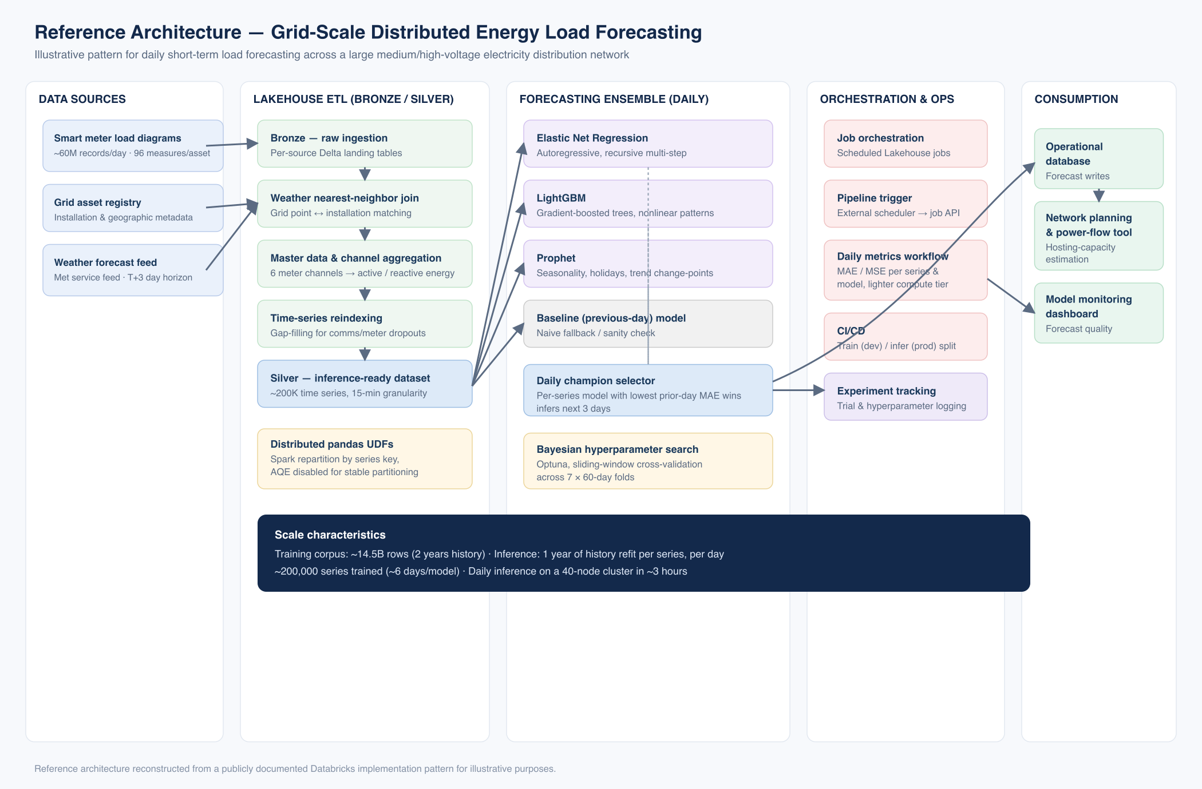
Reference architecture for daily, per-installation short-term load forecasting across a large medium/high-voltage grid.
Figure — Reference architecture (illustrative reconstruction)
6. ARCHITECT'S PERSPECTIVE & APPROACH
The interesting engineering problem here isn't any single model choice — it's the operational discipline of daily per-series champion selection at 200,000-series scale, and the distributed-training mechanics that make it affordable. Fitting that many independent, small models is a pandas-UDF problem, and the pattern's use of manual repartitioning by series key with Adaptive Query Execution explicitly disabled is a trick I've relied on for similar high-cardinality Spark UDF workloads elsewhere in this portfolio — AQE's automatic partition coalescing actively fights you when each task's unit of work is intentionally small and independent, since it tries to merge partitions that were deliberately kept separate for parallelism.
I'd also call out the annual (not monthly) retraining cadence as a pragmatic choice rather than a shortcut: at this series count, a more frequent retrain has a real, quantifiable compute cost, and the daily metrics workflow already gives the team an early-warning signal (rising NMAE/NMSE) if drift starts to outpace the annual cycle — so the retraining interval is set by measured need, not by default.
7. TECHNOLOGY STACK
Azure Databricks ● Delta Lake ● PySpark ● pandas UDFs ● Elastic Net Regression ● LightGBM ● Prophet ● Optuna ● Azure Data Factory ● Lakeflow Jobs ● Azure DevOps CI/CD ● Oracle Database
8. IMPLEMENTATION APPROACH
ETL runs as a sequence of Databricks notebooks: Bronze ingestion of each source, a weather nearest-neighbor join, master-data and channel aggregation, and time-series reindexing to produce the Silver inference dataset. Training and inference are separated by environment (train in a development environment, infer daily in production), orchestrated through scheduled Lakeflow jobs and triggered at a higher level by Azure Data Factory, with the full pipeline managed under Azure DevOps CI/CD.
9. KEY CHALLENGES & HOW THEY WERE ADDRESSED
- Scale of per-series training — addressed with distributed pandas UDFs, manual repartitioning by series key, and AQE disabled to keep partitioning stable under Spark's `applyInPandas`.
- Hyperparameter tuning cost — addressed with Bayesian search (Optuna) instead of grid search, with per-model trial budgets sized to each model's fit cost.
- Weather-to-installation alignment — addressed with a nearest-neighbor spatial join between forecast grid points and physical installations.
- Model drift over time — addressed with an annual retraining cadence backed by a daily metrics workflow tracking MAE/MSE per series and model, giving early warning if drift outpaces the retrain schedule.
10. BUSINESS & TECHNICAL OUTCOMES
- Industry-reported: approximately 200,000 load diagrams forecast daily at 15-minute granularity across the medium- and high-voltage grid.
- Industry-reported: training corpus of roughly 14.5 billion records spanning two years of history.
- Industry-reported: daily inference completes in roughly three hours on a 40-node cluster.
- Industry-reported: generation/load forecasting combined with power-flow analysis is reported to increase grid hosting capacity by 20% or more in some cases.
11. KEY TAKEAWAYS
- At high series-cardinality, the distributed-training mechanics (partitioning, AQE behavior) matter as much as model selection.
- A daily per-series champion-selection pattern beats a single globally-tuned model when series behave heterogeneously.
- Retraining cadence should be set by a measured drift signal, not a calendar default.

